**552552552552552** Prin ciples of Power System

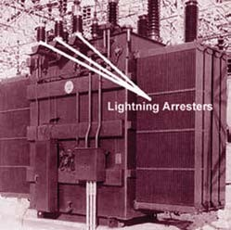

**CONTENTS**

24

C H A P TER

**Protection Against Overvoltages**

# Introduction

* 1. **Voltage Surge**
  2. **Causes of Overvoltages**
  3. **Internal Causes of Overvoltages**
  4. **Lightning**
  5. **Mechanism of Lightning Discharge**
  6. **Types of Lightning Strokes**
  7. **Harmful Effects of Lightning**
  8. **Protection Against Lightning**
  9. **The Earthing Screen**
  10. **Overhead Ground Wires**
  11. **Lightning Arresters**
  12. **Types of Lightning Arresters**
  13. **Surge Absorber**

**T**

here are several instances when the ele ments of a power system (*e.g*. generators, transformers, transmission lines, insulators

etc.) are subjected to overvoltages *i.e*. voltages greater than the normal value. These overvolt- ages on the power system may be caused due to many reasons such as lightning, the opening of a circuit breaker, the grounding of a conductor *etc*. Most of the overvoltages are not of large magni- tude but may still be important because of their effect on the performance of circuit interrupting equipment and protective devices. An appre- ciable number of these overvoltages are of suffi- cient magnitude to cause insulation breakdown of the equipment in the power system. There- fore, power system engineers always device ways and means to limit the magnitude of the overvolt- ages produced and to control their effects on the operating equipment. In this chapter, we shall con- fine our attention to the various causes of over- voltages on the power system with special em- phasis on the protective devices used for the pur- pose.

# Voltage Surg e

*A sudden rise in voltage for a very short dura-*

**552**



**CONTENTS**

*tion on the power system is known as a* **voltage surge** *or* **transient voltage.**



Transients or surges are of temporary nature and exist for a very short duration (a few hundred

*s*) but they cause overvoltages on the power system. They originate from switching and from other causes but by far the most important transients are those caused by lightning striking a transmission line. When lightning strikes a line, the surge rushes along the line, just as a flood of water rushes along a narrow valley when the retaining wall of a reservoir at its head suddenly gives way. In most of the cases, such surges may cause the line insulators (near the point where lightning has struck) to flash over and may also damage the nearby transformers, generators or other equipment connected to the line if the equipment is not suitably protected.



Fig. 24.1 shows the wave-form of a typical lightning surge. The voltage build-up is taken along *y*-axis and the time along *x*-axis. It may be seen that lightning introduces a steep-fronted wave. The steeper the wave front, the more rapid is the build-up of voltage at any point in the network. In most of the cases, this build-up is comparatively rapid, being of the order of 1–5 s. Voltage surges are generally specified in terms of *rise time *t*1 and the time *t*2 to decay to half of the peak value. For example, a 1/50 s surge is one which reaches its maximum value in 1s and decays to half of its peak value is 50 s.

# C auses of Overvoltag es

The overvoltages on a power system may be broadly divided into two main categories *viz*.

1. **Internal causes**

**(*i*)** Switching surges **(*ii*)** Insulation failure

**(*iii*)** Arcing ground **(*iv*)** Resonance

1. **External causes** *i.e*. lightning

Internal causes do not produce surges of large magnitude. Experience shows that surges due to internal causes hardly increase the system voltage to twice the normal value. Generally, surges due to internal causes are taken care of by providing proper insulation to the equipment in the power system. However, surges due to lightning are very severe and may increase the system voltage to several times the normal value. If the equipment in the power system is not protected against lightning surges, these surges may cause considerable damage. In fact, in a power system, the protective devices provided against overvoltages mainly take care of lightning surges.

* It is the time from the beginning of the surge to the peak value.

**554** Prin ciples of Power System



# Internal C auses of Overvoltag es

Internal causes of overvoltages on the power system are primarily due to oscillations set up by the sudden changes in the circuit conditions. This circuit change may be a normal switching operation such as opening of a circuit breaker, or it may be the fault condition such as grounding of a line conductor. In practice, the normal system insulation is suitably designed to withstand such surges. We shall briefly discuss the internal causes of overvoltages.

* + 1. **Switching Surges.** The overvoltages produced on the power system due to switching operations are known as switching surges. A few cases will be discussed by way of illustration :

1. **Case of an open line.** During switching operations of an unloaded line, travelling waves are set up which produce overvoltages on the line. As an illustration, consider an unloaded line being connected to a voltage source as shown in Fig. 24.2.



When the unloaded line is connected to the voltage source, a voltage wave is set up which travels along the line. On reaching the terminal point *A* , it is reflected back to the supply end without change of sign. This causes voltage doubling *i.e*. voltage on the line becomes twice the normal value. If E*r.m.s.* is the supply voltage, then instantaneous voltage which the line will have to withstand will be

2 *E* . This overvoltage is of temporary nature. It is because the line losses attenuate the wave and

2

in a very short time, the line settles down to its normal supply voltage *E*. Similarly, if an unloaded line is switched off, the line will attain a voltage of 2 2 *E* for a moment before settling down to the normal value.

1. **Case of a loaded line.** Overvoltages will also be produced during the switching operations of a loaded line. Suppose a loaded line is suddenly interrupted. This will set up a voltage of 2 *Zn i* across the break (*i.e*. switch) where *i* is the instantaneous value of current at the time of opening of line and \**Zn* is the natural impedance of the line. For example, suppose the line having *Zn* = 1000  carries a current of 100 A (r.m.s.) and the break occurs at the moment when current is maximum. The

voltage across the breaker (*i.e*. switch) = 2  100  1000/1000 = 282·8 kV. If *Vm* is the peak value

2

of voltage in kV, the maximum voltage to which the line may be subjected is = (*Vm* + 282·8) kV.

1. **Current chopping.** Current chopping results in the production of high voltage transients across the contacts of the air blast circuit breaker as detailed in chapter 19. It is briefly discussed here. Unlike oil circuit breakers, which are independent for the effectiveness on the magnitude of the

* It can be shown that natural impedance of the line is given by :

*Zn* =

*L* / *C*

where *L* and *C* are the constants of the line. The term ‘natural’ is used because this impedance has nothing to do with any load, but depends only upon line constants.

Protection Against Overvoltages **555**



current being interrupted, air-blast circuit breakers retain the same extinguishing power irrespective of the magnitude of this current. When breaking low currents (*e.g.* transformer magnetising current) with air-blast breaker, the powerful de-ionising effect of air-blast causes the current to fall abruptly to zero well before the natural current zero is reached. This phenomenon is called current chopping and produces high transient voltage across the breaker contacts. Overvoltages due to current chopping are prevented by resistance switching (See Chapter 19).

* + 1. **Insulation failure.** The most common case of insulation failure in a power system is the grounding of conductor (*i.e*. insulation failure between line and earth) which may cause overvoltages in the system. This is illustrated in Fig. 24.3.



Suppose a line at potential *E* is earthed at point *X* . The earthing of the line causes two equal voltages of *E* to travel along *XQ* and *XP* containing currents *E*/*Zn* and +*E*/*Zn* respectively. Both these currents pass through *X* to earth so that current to earth is 2 *E*/*Zn*.

* + 1. **Arcing ground.** In the early days of transmission, the neutral of three phase lines was not earthed to gain two advantages. Firstly, in case of line-to-ground fault, the line is not put out of action. Secondly, the zero sequence currents are eliminated, resulting in the decrease of interference with communication lines. Insulated neutrals give no problem with short lines and comparatively low voltages. However, when the lines are long and operate at high voltages, serious problem called *arcing ground* is often witnessed. The arcing ground produces severe oscillations of three to four times the normal voltage.

*The phenomenon of intermittent arc taking place in line-to-ground fault of a 3* *system with consequent production of transients is known as* **arcing ground.**

The transients produced due to arcing ground are cumulative and may cause serious damage to the equipment in the power system by causing breakdown of insulation. Arcing ground can be pre- vented by earthing the neutral.

* + 1. **Resonance.** Resonance in an electrical system occurs when inductive reactance of the cir- cuit becomes equal to capacitive reactance. Under resonance, the impedance of the circuit is equal to resistance of the circuit and the p.f. is unity. Resonance causes high voltages in the electrical system. In the usual transmission lines, the capacitance is very small so that resonance rarely occurs at the fundamental supply frequency. However, if generator *e.m.f*. wave is distorted, the trouble of reso- nance may occur due to 5th or higher harmonics and in case of underground cables too.

# Lightning

*An electric discharge between cloud and earth, between clouds or between the charge centres of the same cloud is known as* **lightning.**

Lightning is a huge spark and takes place when clouds are charged to such a high potential (+ve or ve) with respect to earth or a neighbouring cloud that the dielectric strength of neighbouring medium (air) is destroyed. There are several theories which exist to explain how the clouds acquire charge. The most accepted one is that during the uprush of warm moist air from earth, the friction

**556** Prin ciples of Power System



between the air and the tiny particles of water causes the building up of charges. When drops of water are formed, the larger drops become positively charged and the smaller drops become negatively charged. When the drops of water accumulate, they form clouds, and hence cloud may possess either a positive or a negative charge, depending upon the charge of drops of water they contain. The charge on a cloud may become so great that it may discharge to another cloud or to earth and we call this discharge as lightning. The thunder which accompanies lightning is due to the fact that lightning suddenly heats up the air, thereby causing it to expand. The surrounding air pushes the expanded air back and forth causing the wave motion of air which we recognise as thunder.

# Me chanism of Lightning Dischar g e

Let us now discuss the manner in which a lightning discharge occurs. When a charged cloud passes over the earth, it induces equal and opposite charge on the earth below. Fig. 24.4 shows a negatively charged cloud inducing a positive charge on the earth below it. As the charge acquired by the cloud increases, the potential between cloud and earth increases and, therefore, gradient in the air increases. When the potential gradient is sufficient (5 kV*/cm to 10 kV/cm) to break down the surrounding air, the lightning stroke starts. The stroke mechanism is as under :

1. As soon as the air near the cloud breaks down, a streamer called *leader streamer* or *pilot streamer* starts from the cloud towards the earth and carries charge with it as shown in Fig.

24.4 (*i*). The leader streamer will continue its journey towards earth as long as the cloud, from which it originates feeds enough charge to it to maintain gradient at the tip of leader streamer above the strength of air. If this gradient is not maintained, the leader streamer stops and the charge is dissipated without the formation of a complete stroke. In other words, the leader streamer will not reach the earth. Fig. 24.4 (*i*) shows the leader streamer being unable to reach the earth as gradient at its end cloud not be maintained above the strength of air. It may be noted that current in the leader streamer is low (<100 A) and its velocity of propagation is about 0·05% that of velocity of light. Moreover, the luminosity of leader is also very low.

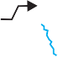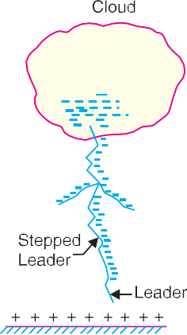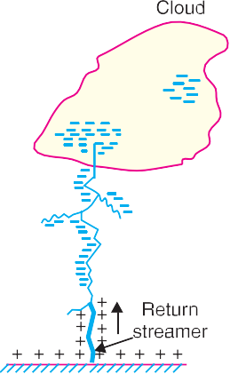

1. In many cases, the leader streamer continues its journey towards earth [See Fig. 24.4 (*ii*)] until it makes contact with earth or some object on the earth. As the leader streamer moves towards earth, it is accompanied by points of luminescence which travel in jumps giving

* It has been found that in a region occupied by droplets of the size expected in the clouds, the breakdown voltage is 5 kV/cm to 10 kV/cm compared to 30 kV/cm in air without droplets. One reason for this is that the low pressure at high altitudes decreases the breakdown gradient.

Protection Against Overvoltages **557**



rise to stepped leaders. The velocity of stepped leader exceeds one-sixth of that of light and distance travelled in one step is about 50 m. It may be noted that stepped leaders have sufficient luminosity and give rise to first visual phenomenon of discharge.

1. The path of leader streamer is a path of ionisation and, therefore, of complete breakdown of insulation. As the leader streamer reaches near the earth, a *return streamer* shoots up from the earth [See Fig. 24.4 (*iii*)] to the cloud, following the same path as the main channel of the downward leader. The action can be compared with the closing of a switch between the positive and negative terminals; the downward leader having negative charge and re- turn streamer the positive charge. This phenomenon causes a sudden spark which we call lightning. With the resulting neutralisation of much of the negative charge on the cloud, any further discharge from the cloud may have to originate from some other portion of it.

The following points may be noted about lightning discharge :

1. A lightning discharge which usually appears to the eye as a single flash is in reality made up of a number of separate strokes that travel down the same path. The interval between them varies from 0·0005 to 0·5 second. Each separate stroke starts as a downward leader from the cloud.
2. It has been found that 87% of all lightning strokes result from negatively charged clouds and only 13% originate from positively charged clouds.
3. It has been estimated that throughout the world, there occur about 100 lightning strokes per second.
4. Lightning discharge may have currents in the range of 10 kA to 90 kA.

# Typ es of Lightning Strokes

There are two main ways in which a lightning may strike the power system (*e.g*. overhead lines, towers, sub-stations etc.), namely;

* + 1. Direct stroke **2.** Indirect stroke

1. **Direct stroke.** In the direct stroke, the lightning discharge (*i.e.* current path) is directly from the cloud to the subject equipment *e.g*. an overhead line. From the line, the current path may be over the insulators down the pole to the ground. The overvoltages set up due to the stroke may be large enough to flashover this path directly to the ground. The direct strokes can be of two types *viz*.
2. Stroke *A* and (*ii*) stroke *B*.

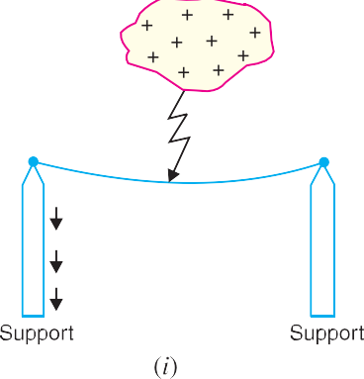

* 1. In stroke *A* , the lightning discharge is from the cloud to the subject equipment *i.e*. an over- head line in this case as shown in Fig. 24.5 (*i*). The cloud will induce a charge of opposite

**558** Prin ciples of Power System



sign on the tall object (*e.g.* an overhead line in this case). When the potential between the cloud and line exceeds the breakdown value of air, the lightning discharge occurs between the cloud and the line.

* 1. In stroke *B*, the lightning discharge occurs on the overhead line as a result of stroke *A* between the clouds as shown in Fig. 24.5 (*ii*). There are three clouds *P*, *Q* and *R* having positive, negative and positive charges respectively. The charge on the cloud *Q* is bound by the cloud *R*. If the cloud *P* shifts too near the cloud *Q*, then lightning discharge will occur between them and charges on both these clouds disappear quickly. The result is that charge on cloud *R* suddenly becomes free and it then discharges rapidly to earth, ignoring tall objects.

Two points are worth noting about direct strokes. Firstly, direct strokes on the power system are very rare. Secondly, stroke *A* will always occur on tall objects and hence protection can be provided against it. However, stroke *B* completely ignores the height of the object and can even strike the ground. Therefore, it is not possible to provide protection against stroke *B*.

1. **Indirect stroke.** Indirect strokes result from the electrostatically induced charges on the conductors due to the presence of charged clouds. This is illustrated in Fig. 24.6. A positively charged cloud is above the line and induces a negative charge on the line by electrostatic induction. This negative charge, however, will be only on that portion of the line right under the cloud and the portions of the line away from it will be positively charged as shown in Fig. 24.6. The induced positive charge leaks slowly to earth *via* the insulators. When the cloud discharges to earth or to another cloud, the negative charge on the wire is isolated as it cannot flow quickly to earth over the insulators. The result is that negative charge rushes along the line is both directions in the form of travelling waves. It may be worthwhile to mention here that majority of the surges in a transmission line are caused by indirect lightning strokes.



# Harmful Effe cts of Lightning

A direct or indirect lightning stroke on a transmission line produces a steep-fronted voltage wave on the line. The voltage of this wave may rise from zero to peak value (perhaps 2000 kV) in about 1 µs and decay to half the peak value in about 5µs. Such a steep-fronted voltage wave will initiate travel- ling waves along the line in both directions with the velocity dependent upon the *L* and *C* parameters of the line.

1. The travelling waves produced due to lightning surges will shatter the insulators and may even wreck poles.
2. If the travelling waves produced due to lightning hit the windings of a transformer or gen- erator, it may cause considerable damage. The inductance of the windings opposes any sudden passage of electric charge through it. Therefore, the electric charges “piles up” against the transformer (or generator). This induces such an excessive pressure between the windings that insulation may breakdown, resulting in the production of arc. While the normal voltage between the turns is never enough to *start* an arc, once the insulation has

Protection Against Overvoltages **559**



broken down and an arc has been started by a momentary overvoltage, the line voltage is usually sufficient to *maintain* the arc long enough to severely damage the machine.

1. If the arc is initiated in any part of the power system by the lightning stroke, this arc will set up very disturbing oscillations in the line. This may damage other equipment connected to the line.

# Prote ction Against Lightning

Transients or surges on the power system may originate from switching and from other causes but the most important and dangerous surges are those caused by lightning. The lightning surges may cause serious damage to the expensive equipment in the power system (*e.g*. generators, transformers etc.) either by direct strokes on the equipment or by strokes on the transmission lines that reach the equip- ment as travelling waves. It is necessary to provide protection against both kinds of surges. The most commonly used devices for protection against lightning surges are :

1. Earthing screen
2. Overhead ground wires
3. Lightning arresters or surge diverters

Earthing screen provides protection to power stations and sub-stations against direct strokes whereas overhead ground wires protect the transmission lines against direct lightning strokes. How- ever, lightning arresters or surge diverters protect the station apparatus against both direct strokes and the strokes that come into the apparatus as travelling waves. We shall briefly discuss these methods of protection.

# The Earthing Screen

The power stations and sub-stations generally house expensive equipment. These stations can be protected against direct lightning strokes by providing earthing screen. It consists of a network of copper conductors (generally called shield or screen) mounted all over the electrical equipment in the sub-station or power station. The shield is properly connected to earth on atleast two points through a low impedance. On the occurrence of direct stroke on the station, screen provides a low resistance path by which lightning surges are conducted to ground. In this way, station equipment is protected against damage. The limitation of this method is that it does not provide protection against the travelling waves which may reach the equipment in the station.

# Overhe ad Ground Wires

The most effective method of providing protection to transmission lines against direct lightning strokes is by the use of overhead ground wires as shown in Fig. 24.7. For simplicity, one ground wire and one line conductor are shown. The ground wires are placed *above* the line conductors at such positions that practically all lightning strokes are intercepted by them (*i.e*. ground wires). The ground wires are grounded at each tower or pole through as low resistance as possible. Due to their proper location, the *ground wires will take up all the lightning strokes instead of allowing them to line conductors.

When the direct lightning stroke occurs on the transmission line, it will be taken up by the ground wires. The heavy lightning current (10 kA to 50 kA) from the ground wire flows to the ground, thus protecting the line from the harmful effects of lightning. It may be mentioned here that the degree of protection provided by the ground wires depends upon the footing resistance of the tower. Suppose, for example, tower-footing resistance is *R*1 ohms and that the lightning current from tower to ground

* The degree of protection by ground wires depends upon the shielding angle (*i.e*. the angle subtended by the outermost line conductors at the ground wire). The lower this angle, the greater the protection.

**560** Prin ciples of Power System



is *I*1 amperes. Then the tower *rises to a potential *Vt* given by ;

*Vt* = *I*1*R*1

Since *Vt* (= *I*1*R*1) is the approximate voltage between tower and line conductor, this is also the voltage that will appear across the string of insulators. If the value of *Vt* is less than that required to cause insulator flashover, no trouble results. On the other hand, if *Vt* is excessive, the insulator flashover may occur. Since the value of *Vt* depends upon tower-footing resistance *R*1, the value of this resistance must be kept as low as possible to avoid insulator flashover.

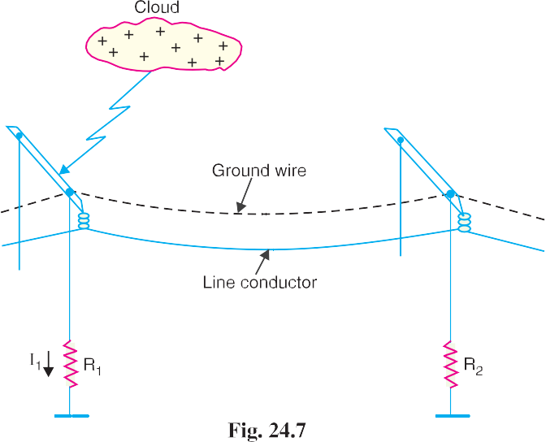

## *Advantages*

1. It provides considerable protection against direct lightning strokes on transmission lines.
2. A grounding wire provides damping effect on any disturbance travelling along the line as it acts as a short-circuited secondary.
3. It provides a certain amount of electrostatic shielding against external fields. Thus it reduces the voltages induced in the line conductors due to the discharge of a neighbouring cloud.

## *Disadvantages*

* 1. It requires additional cost.
  2. There is a possibility of its breaking and falling across the line conductors, thereby causing a short-circuit fault. This objection has been greatly eliminated by using galvanised stranded steel conductors as ground wires. This provides sufficient strength to the ground wires.

# Lightning Arresters

The earthing screen and ground wires can well protect the electrical system against direct lightning strokes but they fail to provide protection against travelling waves which may reach the terminal apparatus. The lightning arresters or surge diverters provide protection against such surges.

*A* **lightning arrester** *or a* **surge diverter** *is a protective device which conducts the high voltage surges on the power system to the ground.*

3

* As a numerical illustration, if *I*1 = 50 kA and *R*1 = 50 , then *Vt* = 50  10  50 = 2500 kV. However, if

3

*R*1 = 10 , then *Vt* = 50  10  10 = 500 kV. Clearly, lesser the tower-footing resistance, smaller the

Protection Against Overvoltages **561**



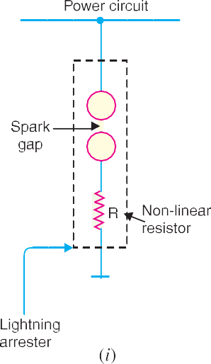

Fig. 24.8 (*i*) shows the basic form of a surge diverter. It consists of a spark gap in series with a

non-linear resistor. One end of the diverter is connected to the terminal of the equipment to be protected and the other end is effectively grounded. The length of the gap is so set that normal line voltage is not enough to cause an arc across the gap but a dangerously high voltage will break down the air insulation and form an arc. The property of the non-linear resistance is that its resistance decreases as the voltage (or current) increases and vice-versa. This is clear from the *volt/amp characteristic of the resistor shown in Fig. 24.8 (*ii*).

**Action.** The action of the lightning arrester or surge diverter is as under :

1. Under normal operation, the lightning arrester is off the line *i.e.* it conducts **no current to earth or the gap is non-conducting.
2. On the occurrence of overvoltage, the air insulation across the gap breaks down and an arc is formed, providing a low resistance path for the surge to the ground. In this way, the excess charge on the line due to the surge is harmlessly conducted through the arrester to the ground instead of being sent back over the line.
3. It is worthwhile to mention the function of non-linear resistor in the operation of arrester. As the gap sparks over due to overvoltage, the arc would be a short-circuit on the power system and may cause power-follow current in the arrester. Since the characteristic of the resistor is to offer high resistance to high voltage (or current), it prevents the effect of a short-circuit. After the surge is over, the resistor offers high resistance to make the gap non-conducting.

Two things must be taken care of in the design of a lightning arrester. Firstly, when the surge is over, the arc in gap should cease. If the arc does not go out, the current would continue to flow through the resistor and both resistor and gap may be destroyed. Secondly, *I R* drop (where *I* is the surge current) across the arrester when carrying surge current should not exceed the breakdown strength of the insulation of the equipment to be protected.

# Typ es of Lightning Arresters

There are several types of lightning arresters in general use. They differ only in constructional details

* The characteristic is drawn between the voltage across the resistance and current through it.

** In actual practice, it may conduct current to ground even at normal supply due to capacitive effects. As the

**562** Prin ciples of Power System



but operate on the same principle *viz*. providing low resistance path for the surges to the ground. We shall discuss the following types of lightning arresters :

**1.** Rod gap arrester **2.** Horn gap arrester

**3.** Multigap arrester **4.** Expulsion type lightning arrester

**5.** Valve type lightning arrester

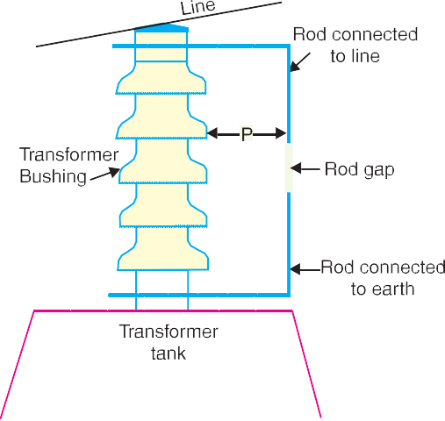

1. **Rod Gap Arrester.** It is a very simple type of diverter and consists of two 1·5 cm rods which are bent at right angles with a gap inbetween as shown in Fig. 24.9. One rod is connected to the line circuit and the other rod is connected to earth. The distance between gap and insulator (*i.e*. distance *P*) must not be less than one-third of the gap length so that the arc may not reach the insulator and damage it. Generally, the gap length is so adjusted that breakdown should occur at 80% of spark- over voltage in order to avoid cascad- ing of very steep wave fronts across the insula- tors. The string of insulators for an overhead line on the bushing of transformer has frequently a rod gap across it. Fig. 24.9 shows the rod gap across the bushing of a transformer.

Under normal operating conditions, the gap

remains non-conducting. On the occurrence of a high voltage surge on the line, the gap sparks over and the surge current is conducted to earth. In this way, excess charge on the line due to the surge is harmlessly conducted to earth.

## *Limitations*

* 1. After the surge is over, the arc in the gap is maintained by the †normal supply voltage, leading to a short-circuit on the system.
  2. The rods may melt or get damaged due to excessive heat produced by the arc.
  3. The climatic conditions (*e.g*. rain, humidity, temperature etc.) affect the performance of rod gap arrester.
  4. The polarity of the surge also affects the performance of this arrester.

Due to the above limitations, the rod gap arrester is only used as a ‘back-up’ protection in case of main arresters.

1. **Horn Gap Arrester.** Fig. 24.10 shows the horn gap arrester. It consists of two horn shaped metal rods *A* and *B* separated by a small air gap. The horns are so constructed that distance between them gradually increases towards the top as shown. The horns are mounted on porcelain insulators. One end of horn is connected to the line through a resistance *R* and choke coil *L* while the other end is effectively grounded. The resistance *R* helps in limiting the follow current to a small value. The choke coil is so designed that it offers small reactance at normal power frequency but a very high reactance at transient frequency. Thus the choke does not allow the transients to enter the apparatus to be protected. The gap between the horns is so adjusted that normal supply voltage is not enough to cause an arc across the gap.

Under normal conditions, the gap is non-conducting *i.e*. normal supply voltage is insufficient to initiate the arc between the gap. On the occurrence of an overvoltage, spark-over takes place across

† The normal supply voltage may not be able to initiate the arc across the gap. But once the arc is started by the surge, the normal voltage is enough to maintain it.

Protection Against Overvoltages **563**





the *small gap *G*. The heated air around the arc and the magnetic effect of the arc cause the arc to travel up the gap. The arc moves progressively into positions 1, 2 and 3. At some position of the arc (perhaps position 3), the distance may be too great for the voltage to maintain the arc. Consequently, the arc is extinguished. The excess charge on the line is thus conducted through the arrester to the ground.

## *Advantages*

* 1. The arc is self-clearing. Therefore, this type of arrester does not cause short-circuiting of the system after the surge is over as in the case of rod gap.
  2. Series resistance helps in limiting the follow current to a small value.

## *Limitations*

1. The bridging of gap by some external agency (*e.g*. birds) can render the device useless.
2. The setting of horn gap is likely to change due to corrosion or pitting. This adversely affects the performance of the arrester.
3. The time of operation is comparatively long, say about 3 seconds. In view of the very short operating time of modern protective gear for feeders, this time is far long.

Due to the above limitations, this type of arrester is not reliable and can only be used as a second line of defence like the rod gap arrester.

1. **Multigap arrester.** Fig. 24.11 shows the multigap arrester. It consists of a series of metallic (generally alloy of zinc) cylinders insulated from one another and separated by small intervals of air gaps. The first cylinder (*i.e*. *A* ) in the series is connected to the line and the other to the ground through a series resistance. The series resistance limits the power arc. By the inclusion of series resistance, the degree of protection against travelling waves is reduced. In order to overcome this difficulty, some of the gaps (*B* to *C* in Fig. 24.11) are shunted by a resistance.

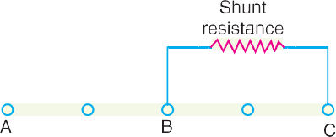

* The arc will occur at the smallest space (*i.e*. gap *G*) between the horns.

**564** Prin ciples of Power System



Under normal conditions, the point *B* is at earth potential and the normal supply voltage is unable to break down the series gaps. On the occurrence of an overvoltage, the breakdown of series gaps *A* to *B* occurs. The heavy current after breakdown will choose the straight - through path to earth *via* the shunted gaps *B* and *C*, instead of the alternative path through the shunt resistance. When the surge is over, the arcs *B* to *C* go out and any power current following the surge is limited by the two resistances (shunt resistance and series resistance) which are now in series. The current is too small to maintain the arcs in the gaps *A* to *B* and normal conditions are restored. Such arresters can be employed where system voltage does not exceed 33 kV.

1. **Expulsion type arrester.** This type of arrester is also called ‘protector tube’ and is com- monly used on system operating at voltages upto 33 kV. Fig. 24.12 (*i*) shows the essential parts of an expulsion type lightning arrester. It essentially consists of a rod gap *A A* in series with a second gap enclosed within the fibre tube. The gap in the fibre tube is formed by two electrodes. The upper electrode is connected to rod gap and the lower electrode to the earth. One expulsion arrester is placed under each line conductor. Fig. 24.12 (*ii*) shows the installation of expulsion arrester on an overhead line.

On the occurrence of an overvoltage on the line, the series gap *A A* is spanned and an arc is struck between the electrodes in the tube. The heat of the arc vaporises some of the fibre of tube walls, resulting in the production of a neutral gas*. In an extremely short time, the gas builds up high pressure and is expelled through the lower electrode which is hollow. As the gas leaves the tube violently, it carries away ionised air around the arc. This de-ionising effect is generally so strong that arc goes out at a current zero and will not be re-established.

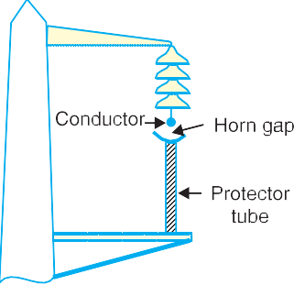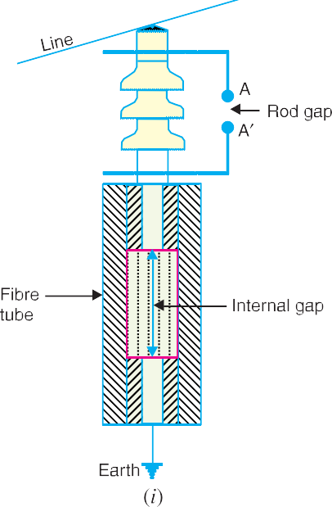

## *Advantages*

* 1. They are not very expensive.
  2. They are improved form of rod gap arresters as they block the flow of power frequency follow currents.
  3. They can be easily installed.
* The gas evolved is an un-ionised mixture of water vapour and decomposition products of the fibre.

Protection Against Overvoltages **565**



## *Limitations*

1. An expulsion type arrester can perform only limited number of operations as during each operation some of the fibre material is used up.
2. This type of arrester cannot be mounted in an enclosed equipment due to the discharge of gases during operation.
3. Due to the poor volt/amp characteristic of the arrester, it is not suitable for the protection of expensive equipment.
4. **Valve type arrester.** Valve type arresters incorporate non-linear resistors and are exten- sively used on systems operating at high voltages. Fig. 24.13 (*i*) shows the various parts of a valve type arrester. It consists of two assemblies (*i*) series spark gaps and (*ii*) non-linear resistor discs (made of material such as thyrite or metrosil) in series. The non-linear elements are connected in series with the spark gaps. Both the assemblies are accommodated in tight porcelain container.
   1. The spark gap is a multiple assembly consisting of a number of identical spark gaps in series. Each gap consists of two electrodes with a fixed gap spacing. The voltage distribu- tion across the gaps is linearised by means of additional resistance elements (called grading resistors) across the gaps. The spacing of the series gaps is such that it will withstand the normal circuit voltage. However, an overvoltage will cause the gap to breakdown, causing the surge current to ground via the non-linear resistors.
   2. The non-linear resistor discs are made of an inorganic compound such as Thyrite or Metrosil. These discs are connected in series. The non-linear resistors have the property of offering a high resistance to current flow when normal system voltage is applied, but a low resis- tance to the flow of high-surge currents. In other words, the resistance of these non-linear elements decreases with the increase in current through them and *vice-versa*.

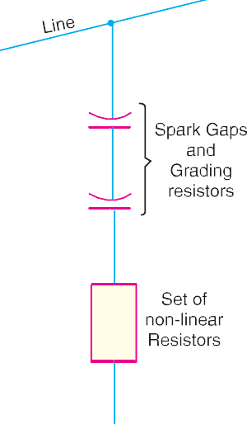

**Working.** Under normal conditions, the normal system voltage is insufficient to cause the break- down of air gap assembly. On the occurrence of an overvoltage, the breakdown of the series spark gap takes place and the surge current is conducted to earth *via* the non-linear resistors. Since the magnitude of surge current is very large, the non-linear elements will offer a very low resistance to the

**566** Prin ciples of Power System



passage of surge. The result is that the surge will rapidly go to earth instead of being sent back over the line. When the surge is over, the non-linear resistors assume high resistance to stop the flow of current.

**Advantages**

1. They provide very effective protection (especially for transformers and cables) against surges.
2. They operate very rapidly taking less than a second.
3. The *impulse ratio is practically unity.

**Limitations**

* 1. They **may fail to check the surges of very steep wave front from reaching the terminal apparatus. This calls for additional steps to check steep-fronted waves.
  2. Their performance is adversely affected by the entry of moisture into the enclosure. This necessitates effective sealing of the enclosure at all times.

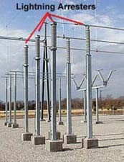**Applications.** According to their application, the valve type arresters are classified as (*i*) station type and (*ii*) line type. The station type arresters are generally used for the protection of important equipment in power stations operating on voltages upto 220 kV or higher. The line type arresters are also used for stations handling voltages upto 66 kV.

# Surge Absorber

The travelling waves set up on the transmission lines by the surges may reach the terminals apparatus and cause damage to it. The amount of damage caused not only depends upon the amplitude of the surge but also upon the steepness of its wave front. The steeper the wave front of the surge, the more the damage caused to the equipment. In order to reduce the steepness of the wave front of a surge, we generally use surge ab- sorber.

A **surge absorber** *is a protective device which reduces the steepness of wave front of a surge by ab- sorbing surge energy.*

Although both surge diverter and surge absorber eliminate the surge, the manner in which it is done is different in the two devices. The surge diverter diverts the surge to earth but the surge absorber absorbs the surge energy. A few cases of surge absorption are dis-

cussed below :

Lightning arresters on bus structures

1. A condenser connected between the line and earth can act as a surge absorber. Fig. 24.14 shows how a capacitor acts as surge absorber to protect the transformer winding. Since the reactance of a condenser is inversely proportional to frequency, it will be low at high fre- quency and high at low frequency. Since the surges are of high frequency, the ***capacitor

* Impulse ratio = Breakdown voltage under surge conditions Breakdown voltage under low frequency conditions

** The normal strokes on transmission lines after travelling along the line are considerably attenuated so that they are well within the reach of protection afforded by such arresters.

*** A pure capacitor, however, cannot dissipate the energy in the wave front of a travelling wave or in a high frequency discharge. It merely reflects the wave energy away from the equipment to be protected and the energy is dissipated in the line resistance and earth resistance.

Protection Against Overvoltages **567**



acts as a short circuit and passes them directly to earth. However, for power frequency, the reactance of the capacitor is very high and practically no current flows to the ground.



1. Another type of surge absorber consists of a parallel combination of choke and resistance connected in series with the line as shown in Fig. 24.15. The choke offers high reactance to surge frequencies *( XL* = 2  *f L*). The surges are, therefore, forced

to flow through the resistance *R* where they are dissipated.



1. Fig. 24.16 shows the another type of surge absorber. It is called Ferranti surge absorber. It consists of an air cored inductor con- nected in series with the line. The inductor is surrounded by but insulated from an earthed metallic sheet called dissipator. This ar- rangement is equivalent to a transformer with short-circuited sec- ondary. The inductor forms the primary whereas the dissipator forms

the short-circuited secondary. The energy of the surge is used up in the form of heat gener- ated in the dissipator due to transformer action. This type of surge absorber is mainly used for the protection of transformers.



Fig. 24.17 (*i*) shows the schematic diagram of 66 kV Ferranti surge absorber while Fig. 24.17 (*ii*) shows its equivalent circuit.

# SELF - TEST

* + 1. **Fill in the blanks by inserting appropriate words/figures :**
       1. The most severe surges on the line are produced by ...............
       2. Lightning produces a fronted wave.
       3. Transients on the power system due to current chopping are taken care of by ...............
       4. Arcing ground can be prevented by ...............
       5. The lightning currents range from 10 kA to about kA.
       6. For successful working of ground wire, the footing resistance of tower should be ...............

**568** Prin ciples of Power System



* + - 1. A surge diverter should be located to the apparatus to be protected.
    1. **Fill in the blanks by picking correct words/figures from brackets :**
       1. A 1/50 µs surge is ............... harmful than 3/50 µs surge. Assume the same peak value.

(*more, less*)

* + - 1. The ............... lightning strokes are very rare on the power system. (*direct, indirect*)
      2. Most of the lightning strokes are due to ............... charged clouds. (*negatively, positively*)
      3. The stroke *A* will always occur on ............... (*tallest object, earth*)
      4. cannot protect the equipment from the travelling waves reaching the equipment.

(*ground wires, lightning arrester*)

* + - 1. In sub-stations, the most commonly used type of arrester is arrester.

(*Thyrite, horn gap, rod gap*)

* + - 1. Surge absorbers are used to ............... the steepness of wave front of the surge. (*reduce, increase*)

ANSWERS TO SELF-TEST

1. (*i*) lightning (*ii*) steep (*iii*) resistance switching (*iv*) earthing the neutral (*v*) 90 (*vi*) low (*vii*) close
2. (*i*) more (*ii*) direct (*iii*) negatively (*iv*) tallest object (*v*) ground wires (*vi*) thyrite (*vii*) reduce

# CHAPTER REVIEW TOPICS

1. What is a voltage surge ? Draw a typical lightning voltage surge.
2. Discuss the causes of overvoltages.
3. What is lightning ? Describe the mechanism of lightning discharge.
4. Describe the various types of lightning stroke.
5. What are the harmful effects of lightning ?
6. How do earthing screen and ground wires provide protection against direct lightning strokes ?
7. What is a surge diverter ? What is the basic principle of operation of a surge diverter ?
8. Write short notes on the following surge diverters :
   1. Rod gap diverter
   2. Horn gap diverter
   3. Expulsion type diverter
   4. Multigap diverter
9. Discuss the construction, principle and working of a valve type arrester.
10. What is a surge absorber ? Write a short note on Ferranti surge absorber.

DISCUSSION QUESTIONS

1. Why are steep fronted surges more dangerous to power system equipment ?
2. Why is lightning accompanied by a thunder ?
3. Is the name lightning arrester appropriate ?
4. Why are surge diverters located very close to the equipment to be protected ?
5. Where will you use a surge absorber ?



GO To FIRST